QUESTION!

Mr. John works in companies with different base salaries. The company requires every employee to include health insurance with a monthly contribution of IDR 27,000.00/person deducted from his basic salary. The nominal amount of health insurance paid by each employee varies depending on the number of family members involved. In addition to being required to participate in health insurance, the basic salary of employees is also subject to a 7% tax. Write a program to calculate the net salary received by employees each month! NB: The program uses Scanner input.

Answer :

Code :

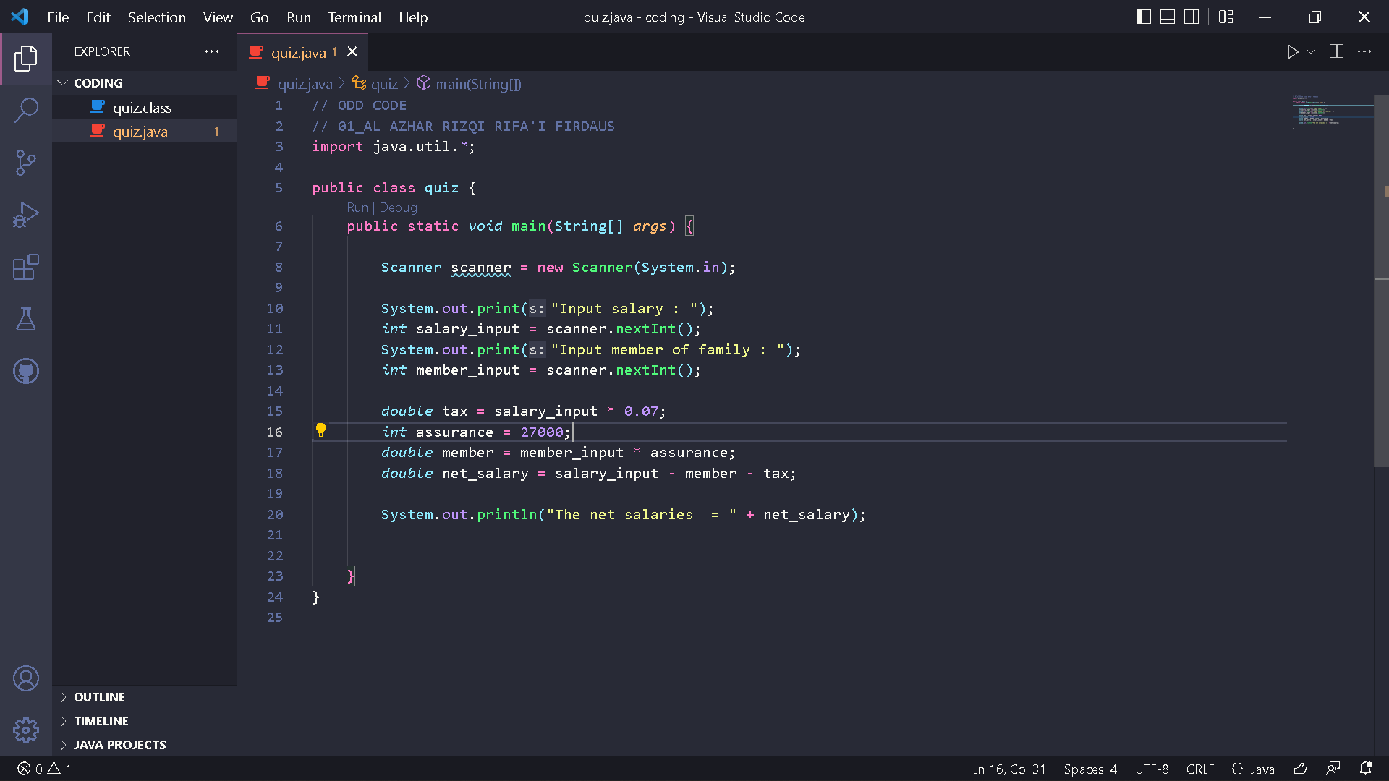

Result :

